

FACULTY OF TECHNOLOGY AND ENGINEERING
DEVANG PATEL INSTITUTE OF ADVANCE TECHNOLOGY AND RESEARCH
DEPARTMENT OF INFORMATION TECHNOLOGY

A.Y. 2026-27 [SEMESTER 3]

LAB MANUAL

CEUE203: Object Oriented Programming


Practical 11

Serialization and NIO file operations
Problem Statement:
1. Save/load: serialize an object array and demonstrate that a transient field is not restored.
2. Log analyzer: count lines and keyword matches across files and report file sizes.
3. NIO tree report: walk a directory and write file names, sizes, and modification times.
Expected Output: The sample programs demonstrate the required behavior; see the captured console output below.

Solution:

LogAnalyzer.java
import java.io.IOException;
import java.nio.file.Files;
import java.nio.file.Path;
import java.nio.file.attribute.BasicFileAttributes;
import java.util.List;
public class LogAnalyzer {
public static void main(String[] args) throws IOException {
Path folder = Files.createTempDirectory("log-analyzer-");
try {
Files.write(folder.resolve("app.log"), List.of("INFO started", "ERROR disk full"));
Files.write(folder.resolve("auth.log"), List.of("INFO login", "ERROR denied"));
int lines = 0;
int matches = 0;
try (var paths = Files.list(folder)) {
for (Path file : paths.toList()) {
BasicFileAttributes attributes =
Files.readAttributes(file, BasicFileAttributes.class);
System.out.println(file.getFileName() + " bytes=" + attributes.size());
for (String line : Files.readAllLines(file)) {
lines++;
if (line.contains("ERROR")) matches++;
}
}
}
System.out.println("Total lines: " + lines);
System.out.println("Lines containing ERROR: " + matches);
} finally {
try (var paths = Files.list(folder)) {
for (Path file : paths.toList()) Files.deleteIfExists(file);
}
Files.deleteIfExists(folder);
}
}
}

NioTreeReport.java
import java.io.IOException;
import java.nio.file.Files;
import java.nio.file.Path;
import java.nio.file.attribute.BasicFileAttributes;
public class NioTreeReport {
public static void main(String[] args) throws IOException {
Path root = Files.createTempDirectory("tree-report-");
Path report = root.resolveSibling(root.getFileName() + "-report.txt");
try {
Files.createDirectories(root.resolve("subfolder"));
Files.writeString(root.resolve("first.txt"), "first file");
Files.writeString(root.resolve("subfolder").resolve("second.txt"), "second file");
StringBuilder output = new StringBuilder("File report for ").append(root)
.append(System.lineSeparator());
try (var paths = Files.walk(root)) {
for (Path path : paths.filter(Files::isRegularFile).toList()) {
BasicFileAttributes attributes =
Files.readAttributes(path, BasicFileAttributes.class);
output.append(path.getFileName()).append(" | ")
.append(attributes.size()).append(" bytes | ")
.append(attributes.lastModifiedTime()).append(System.lineSeparator());
}
}
Files.writeString(report, output);
System.out.println(Files.readString(report));
} finally {
try (var paths = Files.walk(root)) {
for (Path path : paths.sorted(java.util.Comparator.reverseOrder()).toList()) {
Files.deleteIfExists(path);
}
}
Files.deleteIfExists(report);
}
}
}

SerializationDemo.java
import java.io.IOException;
import java.io.ObjectInputStream;
import java.io.ObjectOutputStream;
import java.io.Serializable;
import java.nio.file.Files;
import java.nio.file.Path;
public class SerializationDemo {
private static final class Student implements Serializable {
private static final long serialVersionUID = 1L;
private final String name;
private transient String sessionToken;
Student(String name, String sessionToken) {
this.name = name;
this.sessionToken = sessionToken;
}
}
public static void main(String[] args) throws IOException, ClassNotFoundException {
Path file = Files.createTempFile("students-", ".dat");
try {
Student[] students = {new Student("Riya", "temporary-token")};
try (ObjectOutputStream output = new ObjectOutputStream(Files.newOutputStream(file))) {
output.writeObject(students);
}
try (ObjectInputStream input = new ObjectInputStream(Files.newInputStream(file))) {
Student[] loaded = (Student[]) input.readObject();
System.out.println("Loaded student: " + loaded[0].name);
System.out.println("Transient token: " + loaded[0].sessionToken);
}
} finally {
Files.deleteIfExists(file);
}
}
}

MiniBank Project Work:

MiniBank progress ? Practical 11
Completed: accounts can be serialized and restored; transaction logs append to files; ReportGenerator walks .log files with NIO and writes totals with file metadata.
Single project location: Java Programs\Minibank

Progressive source excerpts:

Minibank/src/main/java/minibank/service/StatePersister.java
package minibank.service;
import java.io.IOException;
import java.io.ObjectInputStream;
import java.io.ObjectOutputStream;
import java.nio.file.Files;
import java.nio.file.Path;
import minibank.model.Account;
public final class StatePersister {
private StatePersister() { }
public static void save(Account[] accounts, Path file) throws IOException {
Path parent = file.toAbsolutePath().getParent();
if (parent != null) Files.createDirectories(parent);
try (ObjectOutputStream output = new ObjectOutputStream(Files.newOutputStream(file))) {
output.writeObject(accounts);
}
}
public static Account[] load(Path file) throws IOException, ClassNotFoundException {
try (ObjectInputStream input = new ObjectInputStream(Files.newInputStream(file))) {
return (Account[]) input.readObject();
}
}
}

Minibank/src/main/java/minibank/service/TransactionLog.java
package minibank.service;
import java.io.IOException;
import java.nio.file.Files;
import java.nio.file.Path;
import java.nio.file.StandardOpenOption;
public final class TransactionLog {
private TransactionLog() { }
public static void append(Path file, String line) throws IOException {
Path parent = file.toAbsolutePath().getParent();
if (parent != null) Files.createDirectories(parent);
Files.writeString(file, line + System.lineSeparator(),
StandardOpenOption.CREATE, StandardOpenOption.APPEND);
}
}

Minibank/src/main/java/minibank/service/ReportGenerator.java
package minibank.service;
import java.io.BufferedReader;
import java.io.IOException;
import java.nio.file.Files;
import java.nio.file.Path;
import java.nio.file.attribute.BasicFileAttributes;
import java.util.regex.Matcher;
import java.util.regex.Pattern;
public final class ReportGenerator {
private static final Pattern TRANSACTION = Pattern.compile("^(DEPOSIT|WITHDRAW)\\s+(\\d+)$");
private ReportGenerator() { }
public static String generate(Path logsFolder, Path reportFile) throws IOException {
long deposits = 0;
long withdrawals = 0;
StringBuilder report = new StringBuilder("MINIBANK END-OF-DAY REPORT\n");
if (Files.isDirectory(logsFolder)) {
try (var files = Files.newDirectoryStream(logsFolder, "*.log")) {
for (Path file : files) {
BasicFileAttributes attributes =
Files.readAttributes(file, BasicFileAttributes.class);
report.append(file.getFileName()).append(" | ")
.append(attributes.size()).append(" bytes | ")
.append(attributes.lastModifiedTime()).append('\n');
try (BufferedReader reader = Files.newBufferedReader(file)) {
String line;
while ((line = reader.readLine()) != null) {
Matcher matcher = TRANSACTION.matcher(line.trim());
if (matcher.matches()) {
long amount = Long.parseLong(matcher.group(2));
if (matcher.group(1).equals("DEPOSIT")) deposits += amount;
else withdrawals += amount;
}
}
}
}
}
}
report.append("Total deposits: ").append(deposits).append('\n')
.append("Total withdrawals: ").append(withdrawals).append('\n');
Path parent = reportFile.toAbsolutePath().getParent();
if (parent != null) Files.createDirectories(parent);
Files.writeString(reportFile, report);
return report.toString();
}
}

Output Screenshot:
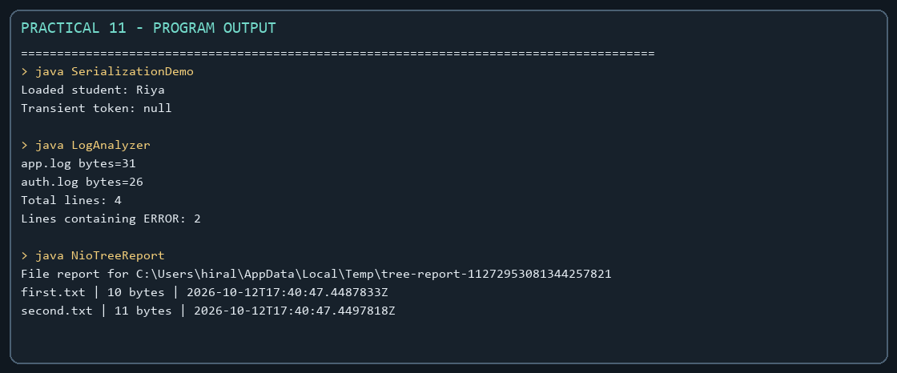

Practical 12

Collections framework
Problem Statement:
1. Word frequency: count words with a HashMap and sort by frequency using a Comparator.
2. Unique visitors: count users with a HashSet and retain first-seen order with LinkedHashSet.
3. Leaderboard: sort scores by descending score and then by player name.

Solution:

Leaderboard.java
import java.util.Comparator;
import java.util.Map;
public class Leaderboard {
public static void main(String[] args) {
Map<String, Integer> scores = Map.of(
"Riya", 94, "Aman", 87, "Dev", 94, "Neha", 78);
scores.entrySet().stream()
.sorted(Map.Entry.<String, Integer>comparingByValue(Comparator.reverseOrder())
.thenComparing(Map.Entry.comparingByKey()))
.limit(3)
.forEach(entry -> System.out.println(entry.getKey() + ": " + entry.getValue()));
}
}

UniqueVisitors.java
import java.util.HashSet;
import java.util.LinkedHashSet;
import java.util.List;
import java.util.Set;
public class UniqueVisitors {
public static void main(String[] args) {
List<String> logins = List.of("riya", "aman", "riya", "dev", "neha", "aman");
Set<String> uniqueUsers = new HashSet<>(logins);
Set<String> firstSeenOrder = new LinkedHashSet<>(logins);
System.out.println("Unique visitors: " + uniqueUsers.size());
System.out.println("First three: " + firstSeenOrder.stream().limit(3).toList());
}
}

WordFrequency.java
import java.util.Comparator;
import java.util.HashMap;
import java.util.Map;
public class WordFrequency {
public static void main(String[] args) {
String paragraph = "Java makes code clear. Java makes programs useful.";
Map<String, Integer> counts = new HashMap<>();
for (String word : paragraph.toLowerCase().replaceAll("[^a-z ]", "").split("\\s+")) {
counts.merge(word, 1, Integer::sum);
}
counts.entrySet().stream()
.sorted(Map.Entry.<String, Integer>comparingByValue(Comparator.reverseOrder())
.thenComparing(Map.Entry.comparingByKey()))
.forEach(entry -> System.out.println(entry.getKey() + ": " + entry.getValue()));
}
}

MiniBank Project Work:

MiniBank progress ? Practical 12
Completed: AccountStore keeps accounts keyed by number in a ConcurrentHashMap, records history, and sorts by balance. Account also implements Comparable by account number.
Single project location: Java Programs\Minibank

Progressive source excerpts:

Minibank/src/main/java/minibank/repository/AccountStore.java
package minibank.repository;
import java.util.ArrayList;
import java.util.Comparator;
import java.util.List;
import java.util.concurrent.ConcurrentHashMap;
import minibank.model.Account;
public final class AccountStore {
private final ConcurrentHashMap<String, Account> accounts = new ConcurrentHashMap<>();
private final List<String> transactionHistory = new ArrayList<>();
public void add(Account account) {
Account previous = accounts.putIfAbsent(account.getAccountNumber(), account);
if (previous != null) throw new IllegalArgumentException("Account already exists.");
}
public Account get(String accountNumber) { return accounts.get(accountNumber); }
public ArrayList<Account> getAll() { return new ArrayList<>(accounts.values()); }
public ArrayList<Account> sortedByBalance() {
ArrayList<Account> sorted = getAll();
sorted.sort(Comparator.comparingLong(Account::getBalance).reversed()
.thenComparing(Account::getAccountNumber));
return sorted;
}
public synchronized void addHistory(String transaction) {
transactionHistory.add(transaction);
}
public synchronized List<String> getHistory() {
return List.copyOf(transactionHistory);
}
}

Minibank/src/main/java/minibank/model/Account.java ? natural account ordering
public final int compareTo(Account other) {
return accountNumber.compareTo(other.accountNumber);
}

Output Screenshot:
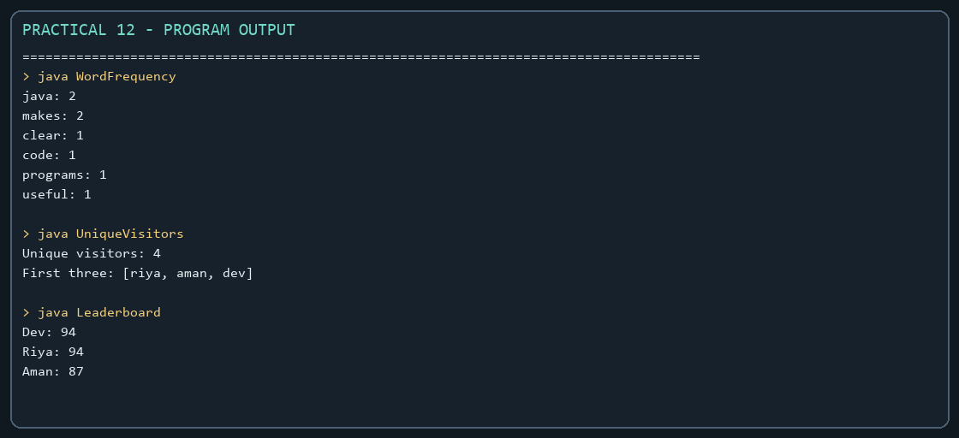

Practical 13

Generics and repositories
Problem Statement:
1. Generic containers: use Box<T>, Pair<A,B>, and a generic first-element method without casts.
2. Bounded stats: calculate averages for arrays of different Number subclasses.
3. Generic stack: reuse a typed stack and handle an empty pop safely.
Expected Output: The sample programs demonstrate the required behavior; see the captured console output below.

Solution:

BoundedStats.java
public class BoundedStats {
public static <N extends Number> double average(N[] values) {
if (values.length == 0) throw new IllegalArgumentException("Values cannot be empty.");
double total = 0;
for (N value : values) total += value.doubleValue();
return total / values.length;
}
public static void main(String[] args) {
System.out.println(average(new Integer[]{2, 4, 6}));
System.out.println(average(new Double[]{1.5, 2.5}));
System.out.println(average(new Long[]{10L, 20L}));
}
}

GenericContainers.java
import java.util.List;
public class GenericContainers {
private record Pair<A, B>(A first, B second) { }
private static final class Box<T> {
private T value;
T get() { return value; }
void set(T value) { this.value = value; }
}
private static <T> T first(T[] values) {
if (values.length == 0) throw new IllegalArgumentException("Array is empty.");
return values[0];
}
public static void main(String[] args) {
Box<String> text = new Box<>();
text.set("Java");
Pair<Integer, String> pair = new Pair<>(7, "days");
System.out.println(text.get());
System.out.println(pair);
System.out.println("First item: " + first(new String[]{"type-safe", "code"}));
List<Integer> values = List.of(1, 2, 3);
System.out.println(values);
}
}

GenericStackDemo.java
import java.util.ArrayList;
import java.util.EmptyStackException;
import java.util.List;
public class GenericStackDemo {
private static final class Stack<T> {
private final List<T> items = new ArrayList<>();
void push(T item) { items.add(item); }
T pop() {
if (items.isEmpty()) throw new EmptyStackException();
return items.remove(items.size() - 1);
}
boolean isEmpty() { return items.isEmpty(); }
}
public static void main(String[] args) {
Stack<String> words = new Stack<>();
Stack<Integer> numbers = new Stack<>();
words.push("Java");
numbers.push(203);
System.out.println(words.pop());
System.out.println(numbers.pop());
System.out.println("Words stack empty: " + words.isEmpty());
}
}

MiniBank Project Work:

MiniBank progress ? Practical 13
Completed: Repository<T> provides reusable CRUD, reads keys from @Id fields with reflection, and supports safe varargs saveAll and bounded numeric averages.
Single project location: Java Programs\Minibank

Progressive source excerpts:

Minibank/src/main/java/minibank/repository/Repository.java
package minibank.repository;
import java.lang.reflect.Field;
import java.util.ArrayList;
import java.util.HashMap;
import java.util.Map;
import minibank.model.annotation.Id;
public final class Repository<T> {
private final Map<String, T> entities = new HashMap<>();
public synchronized T save(T entity) {
entities.put(readId(entity), entity);
return entity;
}
@SafeVarargs
public final synchronized void saveAll(T... items) {
for (T item : items) save(item);
}
public synchronized T findById(String id) { return entities.get(id); }
public synchronized ArrayList<T> findAll() { return new ArrayList<>(entities.values()); }
public synchronized boolean delete(String id) { return entities.remove(id) != null; }
public synchronized int count() { return entities.size(); }
private String readId(T entity) {
if (entity == null) throw new IllegalArgumentException("Entity cannot be null.");
for (Class<?> type = entity.getClass(); type != null; type = type.getSuperclass()) {
for (Field field : type.getDeclaredFields()) {
if (field.isAnnotationPresent(Id.class)) {
try {
field.setAccessible(true);
Object id = field.get(entity);
if (id == null || id.toString().isBlank()) {
throw new IllegalArgumentException("@Id field cannot be empty.");
}
return id.toString();
} catch (IllegalAccessException exception) {
throw new IllegalStateException("Unable to read the @Id field.", exception);
}
}
}
}
throw new IllegalArgumentException("Entity type has no field annotated with @Id.");
}
public static <N extends Number> double average(N[] values) {
if (values.length == 0) throw new IllegalArgumentException("Values cannot be empty.");
double sum = 0;
for (N value : values) sum += value.doubleValue();
return sum / values.length;
}
}

Output Screenshot:
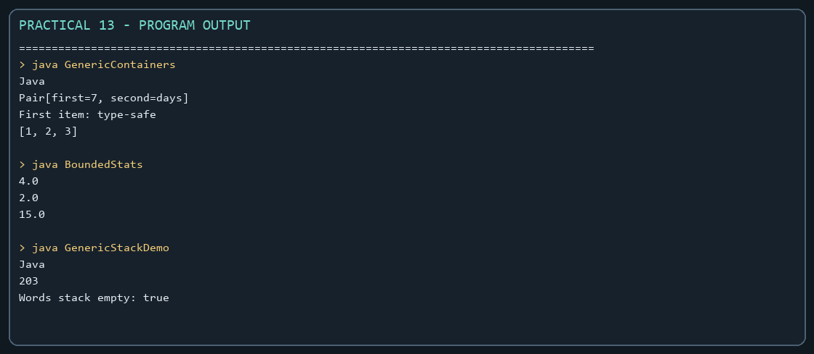

Practical 14

MiniBank capstone integration
Problem Statement:
1. Build a layered model/service/menu application and verify additions and invalid actions with tests.
2. The advanced exercise organizes the application into packages, persists data, and builds a runnable JAR.

Solution:

LayeredApp.java
import java.util.ArrayList;
import java.util.List;
public class LayeredApp {
private record Task(String title) { }
static final class TaskService {
private final List<Task> tasks = new ArrayList<>();
void add(String title) {
if (title == null || title.isBlank()) throw new IllegalArgumentException("Task title is required.");
tasks.add(new Task(title));
}
int count() { return tasks.size(); }
List<Task> all() { return List.copyOf(tasks); }
}
public static void main(String[] args) {
TaskService service = new TaskService();
service.add("Prepare practical");
service.add("Run tests");
System.out.println("Tasks: " + service.count());
service.all().forEach(System.out::println);
try {
service.add("");
} catch (IllegalArgumentException exception) {
System.out.println("Invalid action: " + exception.getMessage());
}
}
}

LayeredAppTest.java
import static org.junit.jupiter.api.Assertions.assertEquals;
import static org.junit.jupiter.api.Assertions.assertThrows;
import org.junit.jupiter.api.Test;
class LayeredAppTest {
@Test
void addingTaskIncreasesCount() {
LayeredApp.TaskService service = new LayeredApp.TaskService();
service.add("Prepare practical");
assertEquals(1, service.count());
}
@Test
void blankTaskIsRejected() {
LayeredApp.TaskService service = new LayeredApp.TaskService();
assertThrows(IllegalArgumentException.class, () -> service.add(" "));
}
@Test
void validTasksAreReturned() {
LayeredApp.TaskService service = new LayeredApp.TaskService();
service.add("Run tests");
assertEquals(1, service.all().size());
}
}

MiniBank Project Work:

MiniBank progress ? Practical 14
Completed capstone: BankService integrates repository, validation, checked errors, transfers, statements, and account listing. MiniBank connects those operations to the console, loads/saves state, generates reports, and handles batch deposits; the central project includes JUnit tests and a runnable JAR.
Single project location: Java Programs\Minibank

Progressive source excerpts:

Minibank/src/main/java/minibank/service/BankService.java ? integrated banking operations
package minibank.service;
import static minibank.util.Validator.isValidAccountNumber;
import java.io.IOException;
import java.nio.file.Path;
import java.util.ArrayList;
import java.util.Comparator;
import java.util.List;
import minibank.exception.AccountNotFoundException;
import minibank.exception.BankException;
import minibank.exception.InsufficientFundsException;
import minibank.exception.InvalidAmountException;
import minibank.model.Account;
import minibank.model.Command;
import minibank.model.SavingsAccount;
import minibank.model.TransactionType;
import minibank.repository.Repository;
import minibank.util.StatementFormatter;
public final class BankService {
private final Repository<Account> accounts;
private final Path logFile;
public BankService(Repository<Account> accounts, Path logFile) {
this.accounts = accounts;
this.logFile = logFile;
}
public Account openAccount(String accountNumber, String owner, long initialBalance,
long minimumBalance) throws BankException, IOException {
if (!isValidAccountNumber(accountNumber)) {
throw new IllegalArgumentException("Use an account number such as AC0001.");
}
if (initialBalance < 0) throw new InvalidAmountException("Initial balance cannot be negative.");
if (accounts.findById(accountNumber) != null) {
throw new IllegalArgumentException("Account already exists.");
}
Account account = new SavingsAccount(accountNumber, owner, initialBalance, minimumBalance);
accounts.save(account);
return account;
}
public void deposit(String accountNumber, long amount) throws BankException, IOException {
Account account = find(accountNumber);
account.deposit(amount);
TransactionLog.append(logFile, "DEPOSIT " + amount);
}
public void withdraw(String accountNumber, long amount) throws BankException, IOException {
Account account = find(accountNumber);
account.withdraw(amount);
TransactionLog.append(logFile, "WITHDRAW " + amount);
}
public void transfer(String fromNumber, String toNumber, long amount)
throws BankException, IOException {
Account from = find(fromNumber);
Account to = find(toNumber);
if (from.equals(to)) throw new IllegalArgumentException("Transfer accounts must differ.");
Account first = Comparator.comparing(Account::getAccountNumber).compare(from, to) < 0
? from : to;
Account second = first == from ? to : from;
synchronized (first) {
synchronized (second) {
from.withdraw(amount);
try {
to.deposit(amount);
} catch (InvalidAmountException | ArithmeticException exception) {
from.deposit(amount);
throw exception;
}
}
}
TransactionLog.append(logFile, "WITHDRAW " + amount);
TransactionLog.append(logFile, "DEPOSIT " + amount);
}
public String statement(String accountNumber) throws AccountNotFoundException {
return StatementFormatter.buildStatement(find(accountNumber));
}
public List<Account> listAccounts() {
ArrayList<Account> result = accounts.findAll();
result.sort(Comparator.comparingLong(Account::getBalance).reversed()
.thenComparing(Account::getAccountNumber));
return result;
}
public Account find(String accountNumber) throws AccountNotFoundException {
Account account = accounts.findById(accountNumber);
if (account == null) throw new AccountNotFoundException(accountNumber);
return account;
}
public void execute(Command command) throws BankException, IOException {
if (command.amount() <= 0) throw new InvalidAmountException("Amount must be positive.");
if (command.type() == TransactionType.DEPOSIT) {
deposit(command.accountNumber(), command.amount());
} else if (command.type() == TransactionType.WITHDRAW) {
withdraw(command.accountNumber(), command.amount());
} else {
throw new IllegalArgumentException("Use the transfer menu for a two-account transfer.");
}
}
}

Minibank/src/main/java/minibank/MiniBank.java ? menu routes
while (running) {
printMenu();
String input = scanner.nextLine().trim();
try {
switch (input) {
case "1" -> openAccount(scanner, bank);
case "2" -> executeCommand(scanner, bank, "DEPOSIT");
case "3" -> executeCommand(scanner, bank, "WITHDRAW");
case "4" -> transfer(scanner, bank);
case "5" -> statement(scanner, bank);
case "6" -> bank.listAccounts().forEach(System.out::println);
case "7" -> System.out.print(
ReportGenerator.generate(LOGS_FOLDER, REPORT_FILE));
case "8" -> processBatch(scanner, bank);
case "9" -> running = false;
default -> System.out.println("Invalid option. Choose 1-9.");
}
} catch (BankException | IOException | IllegalArgumentException exception) {
System.out.println("Operation failed: " + exception.getMessage());
}

Minibank/src/test/java/minibank/BankServiceTest.java ? test evidence
package minibank;
import static org.junit.jupiter.api.Assertions.assertEquals;
import static org.junit.jupiter.api.Assertions.assertThrows;
import java.io.IOException;
import java.nio.file.Path;
import java.util.concurrent.CountDownLatch;
import java.util.concurrent.ExecutorService;
import java.util.concurrent.Executors;
import java.util.concurrent.TimeUnit;
import minibank.exception.InsufficientFundsException;
import minibank.model.Account;
import minibank.repository.Repository;
import minibank.service.BankService;
import org.junit.jupiter.api.Test;
class BankServiceTest {
@Test
void depositIncreasesBalance() throws Exception {
BankService bank = bankWithAccount();
bank.deposit("AC0001", 500);
assertEquals(1500, bank.find("AC0001").getBalance());
}
@Test
void withdrawalOverAvailableBalanceThrows() throws Exception {
BankService bank = bankWithAccount();
assertThrows(InsufficientFundsException.class, () -> bank.withdraw("AC0001", 1500));
}
@Test
void concurrentDepositsKeepBalanceCorrect() throws Exception {
BankService bank = bankWithAccount();
int tasks = 100;
ExecutorService pool = Executors.newFixedThreadPool(8);
CountDownLatch finished = new CountDownLatch(tasks);
for (int i = 0; i < tasks; i++) {
pool.execute(() -> {
try {
bank.deposit("AC0001", 1);
} catch (Exception exception) {
throw new AssertionError(exception);
} finally {
finished.countDown();
}
});
}
pool.shutdown();
if (!finished.await(10, TimeUnit.SECONDS)) {
pool.shutdownNow();
throw new AssertionError("Concurrent deposits timed out.");
}
assertEquals(1100, bank.find("AC0001").getBalance());
}
private static BankService bankWithAccount() throws IOException {
Repository<Account> repository = new Repository<>();
BankService bank = new BankService(repository, Path.of("target", "test-transactions.log"));
bank.openAccount("AC0001", "Riya", 1000, 100);
return bank;
}
}

Output Screenshot:


